MINI PROJECT:

Question 1: Normalize the following table into First Normal Form (1NF)
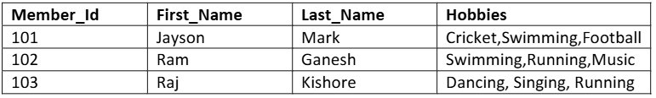

Answer
Member_Id | First_Name | Last_Name | Hobby
101 | Jayson | Mark | Cricket
101 | Jayson | Mark | Swimming
101 | Jayson | Mark | Football
102 | Ram | Ganesh | Swimming
102 | Ram | Ganesh | Running
102 | Ram | Ganesh | Music
103 | Raj | Kishore | Dancing
103 | Raj | Kishore | Singing
103 | Raj | Kishore | Running

Question 2: Normalize the following table into Second Normal Form (2NF)
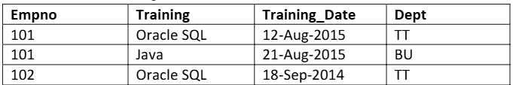

Answer (2NF)
Employee Table
Empno | Dept
101 | TT
102 | TT
Training Table
Empno | Training | Training_Date
101 | Oracle SQL | 12-Aug-2015
101 | Java | 21-Aug-2015
102 | Oracle SQL | 18-Sep-2014

Question 3: Normalize the following table into Third Normal Form (3NF)

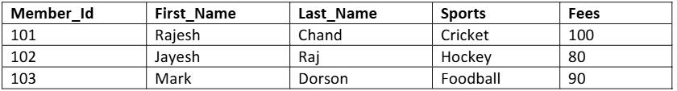Answer
Member Table
Member_Id | First_Name | Last_Name | Sports
101 | Rajesh | Chand | Cricket
102 | Jayesh | Raj | Hockey
103 | Mark | Dorson | Football
Sports Table
Sports | Fees
Cricket | 100
Hockey | 80
Football | 90

